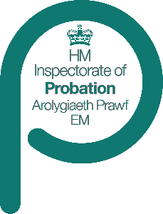

CRC inspection
Case sample specification: Unpaid work
The specification of the sample to be used in
[Name] (CRC) w/c dd/month/yr is set out below.
- We will be looking at a selection of cases during the inspection, drawn from the following:
Sample | Specification
Unpaid work requirements | Please provide details of all unpaid work requirements allocated to the CRC during the period dd/month/yr to dd/month/yr.  This includes stand-alone unpaid work requirements, as well as those on multiple-requirement orders.  It includes cases where the order is managed by the NPS as well as those managed by the CRC.  For cases managed by the CRC, it includes cases allocated to all teams, including non-geographical teams/hubs.
Sample exclusions
The sample should exclude:

- Any cases where the unpaid work requirement has been transferred in from or out to a different CRC

- Any cases which are (or have been during the sample period), subject to a serious further offence review or a serious case review (England)/child practice review (Wales). [delete one]

Otherwise, there should be no exclusions.

Case details: The information we require on each case is set out on the attached spreadsheet: Unpaid work case sample spreadsheet. Please enter all your cases on the relevant sheet, completing the details requested for each case.
Case sample spreadsheet detail
Family name, First name(s), DoB, Gender and Race/ethnicity
This relates to the offender’s details.
Date the unpaid work requirement was allocated to the CRC
This is not always the date that the community order or suspended sentence order was made.
CRN
Please include the case reference number you use for the sentence in question.
PNC
Police national computer number.
Number of Hours
Please specify the number of hours that were ordered by the court.
Risk of Serious Harm [RoSH] classification
Please input the current classification.
Order terminated
This column refers to the order, not the specific unpaid work requirement. Please indicate the termination date if the order has already terminated and was NOT transferred out. If the case is still current within the area, please mark ‘N’.
Agency responsible for management of the requirement
Please indicate here whether the case is managed by the CRC or NPS.
CRC unpaid work team
Please state the geographical team within the CRC responsible for this requirement. If all unpaid work cases are held by a central team, leave this blank.
Cases for inspection will be selected from the long list, during the fieldwork weeks. No shortlist will be identified.
If you have any questions about the selection requirements of the sample, please contact AO on 0161 240 5336.

