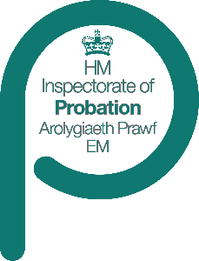

**NPS inspection**

**Case sample specification: Statutory victim contact**

The specification of the sample to be used in   
**[Name] (NPS) w/c dd/month/yr** is set out below.

We will be looking at statutory victim contact in two ways:

* at the start of sentences, a selection of cases during the inspection, drawn from the specific case sample specification below:
* during the immediate pre-release period, where we will draw cases from our core inspection case sample.

|  |  |
| --- | --- |
| Sample | Specification |
| **Commencements of custodial sentences where the case is eligible for statutory victim contact** | Please provide details of **all** new custodial sentences allocated to your NPS division in the specified period **dd/month/yr** to **dd/month/yr** where nature of the offence indicated that the victim was eligible for **Statutory Victim Contact** |
| **Sample exclusions** | |
| The sample should exclude: | |
| * Cases where the prisoner will have been released from custody before **[**fieldwork week **dd/month/yr**. | |
| **Otherwise, there should be no exclusions.** | |

As part of our methodology, we will exclude from the inspection any cases where part or all of the statutory victim contact has been the responsibility of another NPS division.

# Case details: The information we require on each case is set out on the attached spreadsheet, Statutory Victim Contact case sample spreadsheet. Please enter all your cases on the relevant sheet, completing the details requested for each case.

**Case sample spreadsheet detail**

**Family name, First name(s), DoB, Gender and Race/ethnicity**   
This relates to the associated offenders’ details.

**Date of sentence**   
Please enter the date of sentence

**Length of custodial sentence (months)** Please state the length in months of the custodial part of the sentence. For life sentence prisoners, please enter “indeterminate”.

**Index Offence** as recorded on nDelius.

**CRN**Please include the case reference number you use for the order in question.

**PNC**   
Police national computer number.

**Earliest release date** if known.

Cases for inspection will be selected from the long list, during the fieldwork weeks. **No shortlist will be identified.**

If you have any questions about the selection requirements of the sample, please contact **AO** on **0161 240 5336.**