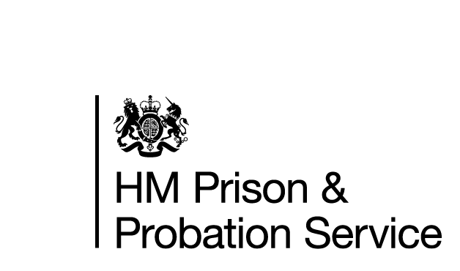

Action Plan: [name of CRC or NPS Division] ----------------
A Response to the HMI Probation Inspection Report
Published --------------------------

Appendix
Action plan
INTRODUCTION

HM Inspectorate of Probation (HMIP) is an independent inspectorate which reports on the effectiveness of work with adults and children and young people who have offended. They report their findings on the quality of services provided across England and Wales to Ministry of Justice (MOJ) and HM Prison and Probation Service (HMPPS). In response to the report, the HMPPS/MOJ are required to draft a robust and timely action plan to address the recommendations. The plan confirms whether recommendations are agreed, partly agreed or not agreed (see categorisations below). Where a recommendation is agreed or partly agreed, the action plan should provide specific steps and actions to address these. Actions within the plan must be clear, measurable, achievable and relevant, with the owner and timescale of each step clearly identified. Action plans are sent to HMIP. It is possible that these will be published at some future point (to be decided). Progress against the implementation and delivery of the action plans will also be monitored and reported on at the next annual inspection.
Term | Definition | Additional comment
Agreed | All of the recommendation is agreed with, can be achieved and is affordable. | The response should clearly explain how the recommendation will be achieved along with timescales. Actions should be as SMART (Specific, Measureable, Achievable, Realistic and Time-bound) as possible. Actions should be specific enough to be tracked for progress.
Partly Agreed | Only part of the recommendation is agreed with, is achievable, affordable and will be implemented.  This might be because we cannot implement the whole recommendation because of commissioning, policy, operational or affordability reasons. | The response must state clearly which part of the recommendation will be implemented along with SMART actions and tracked for progress.  There must be an explanation of why we cannot fully agree the recommendation - this must state clearly whether this is due to commissioning, policy, operational or affordability reasons.
Not Agreed | The recommendation is not agreed and will not be implemented.  This might be because of commissioning, policy, operational or affordability reasons. | The response must clearly state the reasons why we have chosen this option.  There must be an explanation of why we cannot agree the recommendation - this must state clearly whether this is due to commissioning, policy, operational or affordability reasons.

ACTION PLAN: HMIP REPORT
CRC or NPS Division:
1.  Rec No | 2.  Recommendation | 3. Agreed/Partly Agreed/Not Agreed | 4.  Response  Action Taken/Planned | 5.  Responsible / Policy Lead | 6.  Target Date

