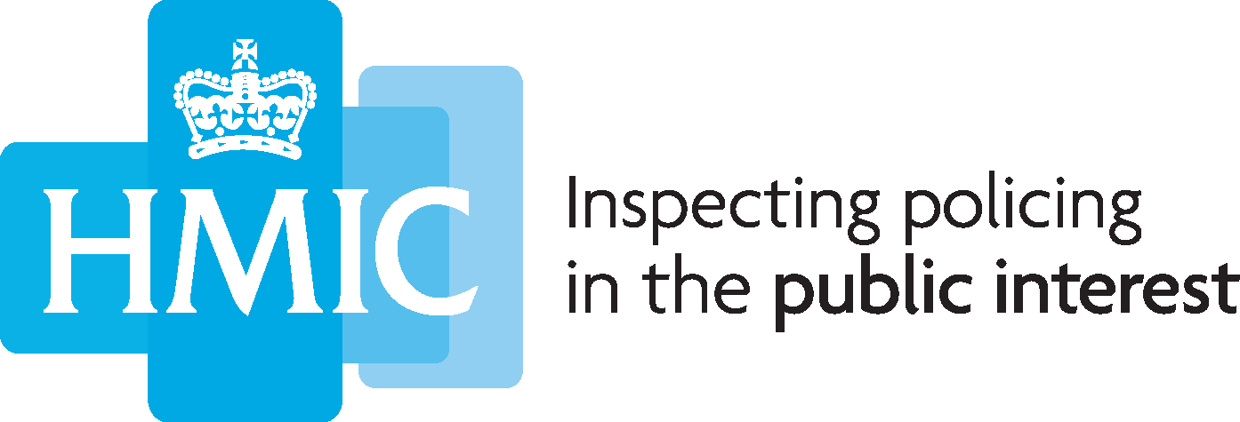
HMIC’s proposed 2015/16 inspection programme: for consultation

Questionnaire template

Consultation response
HMIC is seeking your views on our proposed inspection programme for 2015/16. This comprises national thematic inspections; joint inspections; PEEL assessments; inspections of other national law enforcement agencies; and commissions from the Home Secretary, and police and crime commissioners and other local policing bodies.
The full consultation document can be found at http://www.justiceinspectorates.gov.uk/hmic/publication/hmic-inspection-programme-2015-16-for-consultation/.
The questions in the consultation are listed below. Please include your answers in the boxes below each question.

Q1. Does HMIC's proposed 2015/16 programme include the right areas for inspection?

Q2. Are there further areas that should be included in HMIC's 2015/16 programme?

Q3. Are you aware of any overlap between the areas included in HMIC's proposed 2015/16 programme and work planned or being conducted by other organisations?

Q4. Any further comments?

If you wish, please enter your name:

Please enter your organisation (if applicable):

Please submit this form by email to haveyoursay@hmic.gsi.gov.uk, no later than close on Wednesday 25 February 2015. If you prefer, you can post responses to Ann-Marie Field, Chief Operating Officer, HMIC, 6th floor Globe House, 89 Eccleston Square, London, SW1V 1PN.
If you have a complaint or comment about HMIC’s approach to consultation, you can register this by emailing haveyoursay@hmic.gsi.gov.uk.
How consultation responses will be reviewed
HM Chief Inspector of Constabulary will consider respondents’ views and, if he decides necessary, change the proposed inspection programme before putting it to the Home Secretary for approval. In accordance with the Police Act 1996, Schedule 4A, paragraph 2, the Chief Inspector of Constabulary must obtain the approval of the Home Secretary before publishing his inspection programme.
The results of the consultation will be made available on HMIC’s website at www.justiceinspectorates.gov.uk/hmic/about-us/what-we-do/consultations. Please indicate in your response if you do not wish it to be published (to note, HMIC may summarise responses for publication).
Thank you.

